Don’t wait! Go now!  Visit http://visionsource.com/patients/find-a-doctor/  to find your nearest eye doctor! |  |  | 1)  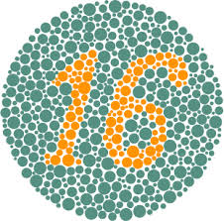  2)  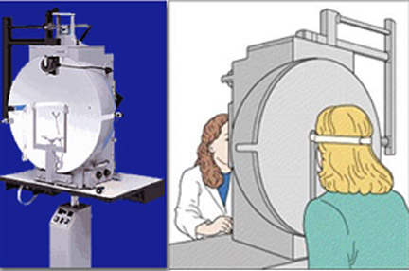 |  |  | What to Expect: Routine Eye Exam  - When’s the last time you have been to see your ophthalmologist?  - If it has been longer than one year, you need to get in there!  - Your eye health is important!

Visual Acuity Test  The most well-known eye test is the Visual Acuity Test done by using the Snellen chart for results. Test subjects are asked to stand 20 feet away and attempt to read the letters as far down as they can. The farthest line read determines their range of sight compared to a normal eyes sight at 20 feet.  - 20/20- vision at 20 feet is normal  - Bottom number greater than 20- You need to be 20+ feet away to see what some can see at 20 feet (ex:20/40)  - Bottom number less than 20- You need to be 20- feet away to see what some can see at 20 feet (ex: 20/15)  - Those without 20/20 may need correction lens. |  |  | Check Eye Muscles  Another common test done by an eye doctor is a simple eye movement test. The doctor will have the patient follow a pen back and forth, up and down, with their eyes.  This test is used to test the Oculomotor 3, Trochlear 4, and Abducens 6 cranial nerve function.  If the eyes are not able to follow the pen, it can indicate damage to the cranial nerves.  Color Vision Test  This test can take many different forms, depending on the doctor. One form is the showing of dot patterns, made up of different colors.  If the patient can distinguish a number from the pattern, their color vision is normal.  However, if the patient cannot distinguish a pattern, they may have color deficiency. Further test will then be run.  *Color deficiency is more common in males than females (1).  Lll  \ll  L  ;  L  K  K  L  Lll  \ll  L  ;  L  K  K  L  Lll  \ll  L  ;  L  K  K  L  Lll  \ll  L  ;  L  K  K  L  Lll  \ll  L  ;  L  K  K  L  Lll  \ll  L  ;  L  K  K  L  Lll  \ll  L  ;  L  K  K  L  Lll  \ll  L  ;  L  K  K  L  Lll  \ll  L  ;  L  K  K  L  Lll  \ll  L  ;  L  K  K  L  Lll  \ll  L  ;  L  K  K  L  Lll  \ll  L  ;  L  K  K  L  Lll  \ll  L  ;  L  K  K  L  Lll  \ll  L  ;  L  K  K  L  Lll  \ll  L  ;  L  K  K  L |  |  | Refraction Assessment  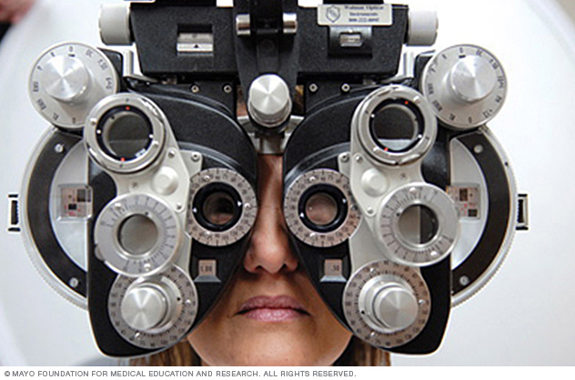  First, the doctor will shine a light in your eyes to see how the light refracts.  Then, the patient will sit down while the doctor adjusts a phoropter (pictured above) in front of the eyes.  The test will shift through different rounds of lens to see what is the clearest for the patient.  The results of the test will determine what prescription lens the patient needs, if any.  Tangent Screen Exam  In this test, the patient will be asked to sit a short way away from the machine and focus on an object, which will be centered in the machine.  You will not be able to move your head to see, as it tests your peripheral or side vision.  This test will determine your range of vision (2).

